

Azure VM Agent
Manual Installation Guide

12/18/2019

10th Magnitude, LLC
20 North Wacker Drive #530
Chicago, IL 60606

Notice of Confidentiality © 2018 10th Magnitude, LLC All rights reserved

THIS DOCUMENT IS 10TH MAGNITUDE PROPRIETARY AND CONFIDENTIAL INFORMATION AND IS SUBJECT TO THE TERMS OF THE 10TH MAGNITUDE NON-DISCLOSURE AGREEMENT. NEITHER THIS DOCUMENT NOR ITS CONTENTS MAY BE REVEALED OR DISCLOSED TO UNAUTHORIZED PERSONS OR SENT OUTSIDE THE AFOREMENTIONED COMPANY WITHOUT PRIOR PERMISSION FROM 10TH MAGNITUDE.
Table of Contents
Summary 3
Agent Installation 4
Windows 4
GUI Installation 4
Command Line Installation 6
Linux 7
Ubuntu 15.04+ 7
Red Hat/CentOS 7 7

Summary
This document Is Intended to describe the manual Install process of the Azure VM agent. The Azure VM agent Is a lightweight agent that Is Installed on a VM guest OS to enable Interaction with the Azure Fabric controller. The Installation of the agent allows functionality such as extensions, several Image provisioning features, console redirection to the serial port, and more. For more Information, please visit the following Microsoft documentation sites:
https://docs.microsoft.com/en-us/azure/virtual-machines/extensions/agent-linux
https://docs.microsoft.com/en-us/azure/virtual-machines/extensions/agent-windows

Agent Installation
This section outlines steps installing the agent on Windows and the Ubuntu and Red Hat Linux distributions. Other Linux distributions are supported. More details about the agents and supported operating systems can be found here:
https://docs.microsoft.com/en-us/azure/virtual-machines/extensions/agent-windows
https://docs.microsoft.com/en-us/azure/virtual-machines/extensions/agent-linux
https://github.com/Azure/WALinuxAgent

Windows

GUI Installation

- The Windows VM agent can be manually installed with a Windows installer package. Download the installer here - https://go.microsoft.com/fwlink/?LinkID=394789
- Run the installer and click next.

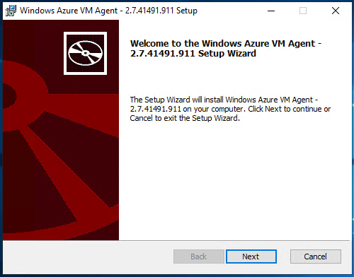

- Accept the License Agreement and click Next

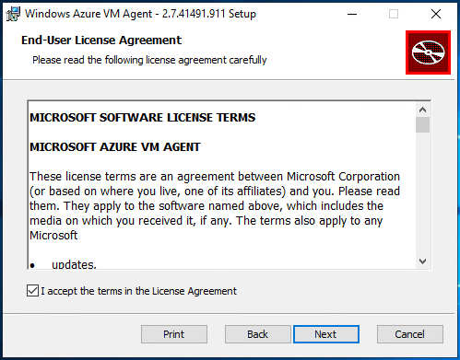

- The agent installation starts

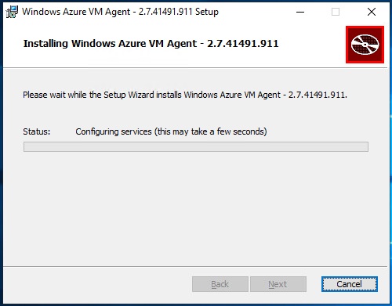

- Click Finish to finish the installation. No reboot is required.

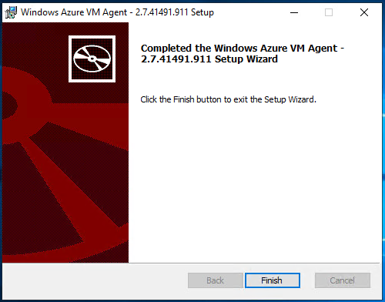

Command Line Installation

- Download the installer here - https://go.microsoft.com/fwlink/?LinkID=394789
- From an elevated command prompt, run the following command:
msiexec.exe /i WindowsAzureVmAgent.<version and build>.msi /quiet
Example:
msiexec.exe /i WindowsAzureVmAgent.2.7.1198.778.rd_art_stable.160617-1120.fre.msi /quiet
- The package can also be used for scaled deployments with automation tools such as SCCM, or used in a Group Policy software deployment.

Linux

Ubuntu 15.04+

- Run the following command to install the latest package version:
sudo apt-get install walinuxagent
- Verify the service is enabled so it automatically starts on boot. Run the following:
systemctl is-enabled walinuxagent
The output should be enabled. If it isn’t, enable using step 3.
- Enable the service so that it automatically starts on boot:
sudo systemctl enable walinuxagent

Red Hat/CentOS 7

- Run the following command to install the latest package version:
sudo yum install WALinuxAgent
- Verify the service is enabled so it automatically starts on boot. Run the following:
systemctl is-enabled waagent
The output should be enabled. If it isn’t, enable using step 3.
- Enable the service so that it automatically starts on boot:
sudo systemctl enable waagent

Note:
Pre-installing the Azure VM agent on machines prior to migration can cause the agent to output errors to the console. This output is normal as the agent is trying to communicate with the Azure fabric. If this is potential problem or concern, it may be a good idea to install the agent shortly before migration, or after migration.

For more information and installation information for other supported distributions, visit the following Microsoft Documentation sites:

https://docs.microsoft.com/en-us/azure/virtual-machines/extensions/update-linux-agent
https://github.com/Azure/WALinuxAgent

